Get Ready to Dominate
Your Niche with the…

Article Domination
Method


By: Kevin A. Koop

Brought to you by:
Legal “Mumbo-Jumbo”

The information contained in this ebook contains the opinions of the author as of the date of this publication. Because the Internet moves at warp-speed, the author reserves the right to alter/update his opinion in the future.

This ebook has been provided for informational purposes only. While every attempt has been made to ensure it’s accuracy, neither the author nor his affiliates/partners assume any responsibility for errors, inaccuracies or omissions. After all, they’re only human!

The author isn’t a legal professional nor does he claim to be. If you need any legal, business or accounting advice, you should seek the guidance of a professional in your area.

Any slights of persons or organizations are unintentional.

Disclaimers. While the information contained in this ebook has been proven to work for the author, he makes no specific guarantees in regards to the outcome you’ll experience. Why, you ask? Well, solid information is great and all, but it doesn’t do any good if it just stays stuck in your head. In order for this information to work, you must take action!

Your level of success will largely depend on the time you devote to the information presented, and the amount of action you take. Since these factors will vary from individual to individual, we cannot guarantee your success, nor are we responsible for any of your actions. Please note: This is not a “get rich quick scheme,” nor do we purport it to be.

Any pricing mentioned in this book was determined to be accurate at the time of release. However, we have no control over the third-party websites we may have mentioned, so be sure to review their offerings if you decide to do business with them.

Worldwide Rights Reserved. Unless you own “Master Resell Rights” to this ebook you are forbidden to reproduce, transmit or distribute it in any form whatsoever, without the prior permission (dated and signed) from the author.

Table Of Contents

Introduction 4
Anatomy Of A Successful Article 5
What’s So Great About “Article Marketing” Anyway? 9
Overview Of The “Article Domination Method” 13
- Step#1: Keyword Research 14
- Step#2: Choose Your Article Format: 3 Proven Types 22
- Step#3: 5 Quick, Creative Techniques To Get Article Content 24
- Step#4: How To Write A “Killer” Article Title 30
- Step#5: How To Write A Quality, Keyword Rich Article 31
- Step#6: How To Craft A Compelling Resource Box 40
- Step#7: Locate Article Submission Outlets 43
- Step#8: How To Efficiently Submit Your Articles 44
- Step#9: Step-by-Step Marketing Plan For Niche Domination 51
33 Quality Article Directories You Can Submit To For FREE 54
Summary 56
Valuable Resources 57
Internet Marketing Resources 63
Make Money With This Book 65
About The Author 67

Introduction

First off, I’d like to say “Thanks” for your investment in my ebook. I truly
believe you’ll find it to be one of the best Internet Marketing values on the topic of Article Marketing.

I’ve chosen the topic, Gardening, to illustrate the “Article Domination Method” and to keep the learning focused. Please note: I know very little
about the subject of Gardening (as my wife can attest to).

Also, I am not currently involved in this niche. That’s not to say it isn’t a profitable niche, it probably is.

Who knows, maybe you’re into gardening and can gain some insight into exploiting this niche as an added bonus!

Stop the presses! I just got back from the bookstore and found over 20 different magazines devoted to gardening. I knew it was popular… but not THAT popular! This is a sure sign that there is money to be made in this niche!

Before we plunge into the “Article Domination Method,” I’d like to discuss the anatomy of a successful article and show you visual proof of just how powerful Article Marketing can be.

Ready? Then let’s go!

Anatomy Of A Successful Article

Every article contains three primary elements; the Title, the Article Content and the Resource Box (aka Bio Box). We’ll cover the basics now, and go into greater detail before we’re done.
Following the article, written by Internet Marketer, and Software Designer, Jonathan Leger, I’ll discuss its strengths. This will give us a solid foundation on which to build.

SEO Made Easy Part 3 of 5:
Let the Search Engines Know Your Page is Relevant
In parts one and two of this five part tutorial, I discussed how to select and analyze the keywords that you should try and rank your page for. In this article I’ll discuss how to format your page in such a way that the search engines know it is relevant to your chosen keywords. This process is known as “on-page optimization”.
Step 3: On-Page Optimization
There are two kinds of search engine optimization: on-page and off-page. On-page optimization is the stuff you do to your actual web page that will help it get ranked. Off-page optimization means stuff that isn’t on the page that affects your ranking (namely, in-bound links). Both are important. For Yahoo and MSN, on-page is more important than it is for Google. Google relies more heavily on links than the other big two, though Yahoo and MSN also weight links heavily.
In this case, I wanted to optimize the home page of the feline photos blog for the phrase “cat pictures”. This is how I normally do this:
1. Make sure the domain name contains the keywords.
2. Make the title of the page my exact keywords I am targeting, capitalized appropriately.
3. Make the very first text on the page the keywords in an H1 (header) tag.
4. Put an introductory paragraph that uses the keywords right after the H1 tag.
5. If I have a lot of text on the page, break it up with H2 tags that contain variations of my keywords.
Unfortunately, catpictures.blogspot.com was not available, so I couldn’t do #1. Since competition for “cat pictures” was somewhat light, I knew that I could get by without worrying about it. But if you are targeting more competitive keywords, make sure that your domain name (or subdomain name) contains the exact phrase you want to rank for. This especially helps for MSN.
Also, I didn’t do number five for my feline photos blog, because being a picture gallery there wasn’t that much text on the page. But I’ll give you more detail on how that works in case your page does have a lot of text.
Let’s say that I have an article on pontoon boats that I want to rank for the phrase “pontoon boats”. This is what I would do for the on-page optimization: Try and get a domain name with the words “pontoon boats” in it (www.pontoonboats.com would be perfect). If there isn’t anything available, then setup a subdomain for it (pontoonboats.mydomain.com).
Make the page title “Pontoon Boats”, put the H1 tag at the beginning of the text as “Pontoon Boats”, then break up the article with H2 subheadings like “Maintaining Pontoon Boats”, “Pontoon Boats for Fishing”, “Are Pontoon Boats Fast?”, etc. You don’t want your subheadings to be exactly your keywords like the main H1 heading and the title, but you want the subheadings to contain your keywords.
That’s really all I do with on-page optimization, and as I said before, if the competition is light I don’t always do all five of those things.
There are other things that search engine marketers focus on and spend a lot of time with (things like keyword density and image alt tag density, etc.), but since I don’t try to rank for fiercely competitive keywords I don’t usually bother with all of that. I leave the ranking of really tough keywords to the serious SEO gurus, because to me it’s just too much dang work.
To me, ranking for really competitive keywords is like owning a boat: it requires far too much time, money and effort to maintain to be worth the end result (going to the lake three times a year–sorry boat owners!).
No thanks. I’ll rank for moderately competitive keywords and only have to do a little bit of maintenance every now and again, and by multiplying that effort I’ll earn 10 times the advertising revenue that I would if I focused on one tough set of keywords.
What’s Next?
Once you’ve got your page properly optimized for your chosen keywords, it’s time to get to the “hard” part: getting in-bound links to your site. I quote “hard” because it’s not really difficult, just tedious. However, in the last part of this tutorial I will show you a tool that makes all of the work of gathering in-bound links much, much easier.
===========================================================
Jonathan Leger is the creator of the first commercial AdSense Tracker script packages available, which has grown into the widely-popular product set, AdSenseGold.com
The full 5 part SEO tutorial is also available in an ebook which you can download from: http://AdSenseGold.com/downloads/AdSenseSEO.pdf

Alright, now that you’ve read the article, I’ll give you a quick overview of what makes it successful:

Title: The Title clearly states the BENEFITS the reader will enjoy if they read the article… in this case, the ability to “easily” understand Search Engine Optimization. It also contains well-selected Keywords. (more on this is a bit)

Article Content: The Article Content, also called the body text, is both useful and entertaining to read. Please note: The content is written in a manner that is likely to be enjoyed by the reader and does not read like a sales letter.

Note: Many article writers blow this and their “circulation” suffers tremendously!

Resource Box: The Resource Box is the area where you get to “sell” yourself and entice the reader to click the link you’ve supplied to get more information. As in this resource box, it’s important you give the reader the opportunity to learn more through the link(s) you provide.

Note: Do not try to “close the sale” in your resource box, there isn’t enough space. Simply entice the reader with an offer for more information and let the website do the selling!

There are two other elements you need to supply the article directories before your articles will be accepted. This includes a short paragraph summarizing your article and a list of keyword/keyword phrases which are relevant to your article.

Now then, before we dissect Article Marketing, and the “Article Domination Method,” I need you to get pumped up! I can tell you how important this is for your online business but unless you see it for yourself you may not follow through… and that would be a crying shame!

The next section, entitled “What’s So Great About ‘Article Marketing’ Anyway?” should do the trick! If it doesn’t, check your pulse.

What’s So Great About “Article Marketing” Anyway?

More than likely, you’re already aware of the benefits Article Marketing offers as the concept has been around for a while. That being said, you may not have seen the “full picture,” and it’s important you do.

The more benefits you are aware of, the more driven you’ll be to incorporate Article Marketing into your overall marketing plan. It is my sincere goal to show you how to dominate your niche using the “Article Domination Method” as one of the driving forces.

As an aside, I’m mentored by Matt Bacak, who’s known online as the Powerful Promoter. When I was with him last, in Atlanta, Georgia, I asked him which marketing methods had benefited him most. Which ones he wouldn’t stop doing… EVER!

His answer: Joint Ventures and ARTICLE MARKETING!

Before I get down to the “nitty-gritty,” I thought I’d give you visual proof of just how how powerful Article Marketing is.

An ebook, entitled “Day Job Killer,” was recently launched. The “book” has sold like crazy and has broken all sorts of records at ClickBank. Would you like to have top search engine placement for the phrase “Day Job Killer,” which is one of the most searched phrases for perspective buyers of the “book?” I would!

Well, check out the screen-shot on the next page!
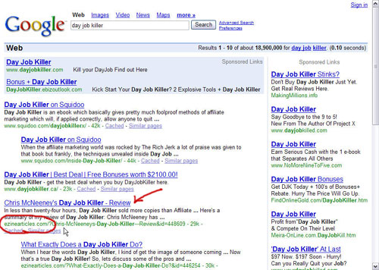

You’re looking at a search performed on Google for “Day Job Killer.” While there are countless affiliates paying for Adwords Traffic, the 4th & 5th listings in the organic results (the free search) point to articles about the “Day Job Killer” ebook on the EzineArticles.com website.

Want to know where the resource box links go? Well, the article that’s been circled in red has two outbound links from the resource box. One goes to the gentleman’s blog, where he offers more information and a whole host of affiliate programs. The other, goes to a squeezepage that has been set up specifically for those interested in more information about “Day Job Killer.”

The article below it has only one outbound link. The author has provided an affiliate link which redirects directly to the sales page of “Day Job Killer.”

Think either of them has made any money? You betcha!

Do I have your attention? Great!

There are many reasons that Article Marketing is so powerful but it really all boils down to these three: Credibility, Targeted Website Traffic, and Search Engine Rankings! I’ll do my best to explain…

Credibility

Authors have always received respect and special treatment from our society, and authors of quality articles are no different. The author of an article, especially one that is well-written, is deemed to be an expert by the reader, and the content is generally considered to be unbiased and credible.

To enhance this, you’ll receive “Expert Author” status from EzineArticles.com after they’ve accepted and published your articles. You’re even given an Expert Author icon you can put on your website or blog (if you choose).

Targeted Website Traffic

There are many ways your articles will bring targeted traffic (and we’ll be discussing this more in depth later). For now, I’ll cover the two primary routes.

First, web surfers will type in your keyword phrase into their search engine of choice, and will find your articles in the organic search listings. After visiting the site and reading your article, they’re given the opportunity to know more about you, or your product or service by the link provided in your resource box.

Second, because the “Article Domination Method” will skyrocket your website’s incoming links, your site’s search engine rankings will dramatically improve and help your website get found in the organic search listings as well. This will also help you accelerate your site’s PageRank as sites that have a lot of incoming links from “authority sites” are themselves considered important.

Search Engine Rankings

Now then, this isn’t intended to be a full-blown course in SEO but I’m going to give you an overview of how the search engines work, and how the “Article Domination Method” goes hand-in-hand.

The search engines consider the “anchor text” of your incoming links and also record when they first discovered them.

Now, not all article directories allow you to use “anchor text” links (also referred to as hyper-linked text) but many do… more on this later!

Most search engines want to see a variety of “anchor text” links coming into a site.

This is easily accomplished, as you can “change-up” your “anchor text” as often as you’d like.

If a site receives a quick surge of incoming links, the search engines will view them as “suspect” unless a good portion of them come from “authority sites.”

Since the vast majority of the sites we’ll be submitting to are considered “authority sites” by the search engines, we’ll keep the benefit they provide.

The search engines record (and consider) the appearance and disappearance of a link over time.

Most of the article directories will keep your articles on their site indefinitely so your links will grow over time rather than dwindle away.

The search engines generally give a higher value to links with a long life span.

As mentioned previously, most of your links will remain intact for many years and will be valued by the search engines accordingly.

The search engines like sites that “grow naturally.” By that I mean, new pages are added or content is updated on the site semi-regularly. This is a problem for most of us, as we generally operate Mini-Sites which don’t see a lot of growth or change. The good news is, most search engines consider a site “growing” if it continues to build incoming links.

Consistent Article Marketing will guarantee that a site’s incoming links continue to grow.
Most search engines place more value on a site which receives slow, constant growth in regards to its incoming links.

Using the “Article Domination Method,” your site will continue to grow its incoming links and since the vast majority will come from “authority sites,” you reap your reward… Improved organic search placement and Free Targeted Website Traffic.

Overview Of The “Article Domination Method”

Basically, the “Article Domination Method” is a step-by-step process designed to help you quickly write quality articles loved by the Article Directory Editors, your Target Market and the Search Engines.

Beyond that, it teaches several methods for efficient article submission and teaches you how to get more mileage out of each and every article you write!

Now then, before we hit the ground running, let me give you a tip. I strongly suggest you get yourself a blank spiral notepad to keep all the research you’ll perform for a given niche.

I keep a spiral notepad for all my handwritten notes and I also keep a three-ringed binder to hold all the printouts I’ll make from my web-based research.

PRO Tip- Load your computer printer with paper that is pre-punched with the three-hole pattern. That way, when you print out your research it can be placed directly into your notebook.

Onto Step #1!

Step #1: Keyword Research

If you intend to be successful in Internet Marketing, and I know you do, then I suggest you fall in love with Keyword Research. Why?.. Because in order to bring targeted visitors to your site (and make sales) you need to be found.

Sure, you could bring visitors to your site through Pay-Per-Click advertising (and I plan to cover how to do this effectively in an up-coming book) but it shouldn’t be your only traffic source. Successful Internet Marketers realize the importance for “multiple streams of traffic” just as much as “multiple streams of income.”

The vast majority of websites are found through the search engines. Web searchers enter their search terms (i.e. keywords) into the search engine and click the [Search] button. The search engines return web pages they believe to be relevant. Relevant to what? The Keyword that was entered!

In my opinion, you have to enjoy Keyword Research to get really good at it. I liken it to an Easter egg hunt. You have to search and dig around a bit before you find the prize. If you treat it like a game, you’ll do it more often and get better at it!

I’m going to show several ways to come up with keyword ideas. Some are free, some require a modest, one-time fee and others require an ongoing monthly membership. All are valid, but since you’ll be doing keyword research for the rest of your Internet Marketing “career,” I suggest you look into an efficient tool as the time-savings can be tremendous.

Free method #1:

You probably expect me to suggest going to Inventory.Overture.com but the tool, which is owned by Yahoo, hasn’t been available for a while and many speculate it will never return. Don’t worry, I’ve got your back!

You may have heard of WordTracker, a web-based keyword research tool. Wordtracker’s service is really good but it’s also rather pricey. Fortunately, they offer a free keyword tool at: http://www.freekeywords.wordtracker.com/

It’s somewhat basic, but it’s easy to use and the results are good AND free.

The screen-shot on the next page will show you what the interface looks like.
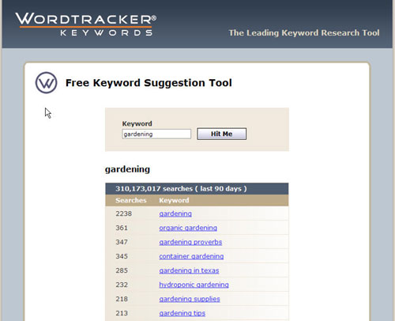

As you can see, I’ve entered our Primary Keyword, Gardening into the suggestion tool and clicked [Hit Me]. The tool brought up the top 100 keyword phrases, measured in search volume, which contained the Primary Keyword.

Now, I don’t pay too much attention to the search volume as many tend to get caught up in the debate of “how many searches is too many” or “how many searches is not enough.” Really, what I’m looking for is related keyword phrases and I note which ones are being searched on more frequently, and which ones less so. I like to keep things simple!

As a general rule, I’ll note any keyword/keyword phrase that makes sense for the product I’ll be promoting (or offering, if it’s my own) and I’ll keep them in order in regards to search volume. I’ll usually stop when the search volume gets to about 100.

In this search, Gardening shows a search volume of 2,238 – Organic Gardening, 361 – Container Gardening, 345 – Hydroponic Gardening, 232 – Gardening Supplies, 218 – and Gardening Tips, 213. This is good for now.
Free method #2:

This is a slick little tool and I’m surprised how few marketers I talk to know about it. As a matter of fact, I know a bunch of Adwords Advertisers who haven’t seen it either. It’s a tool, offered by Google, to aid Adwords Advertisers in their keyword research.

You’ll find it at: https://adwords.google.com/select/KeywordToolExternal

Here’s a shot of the interface.

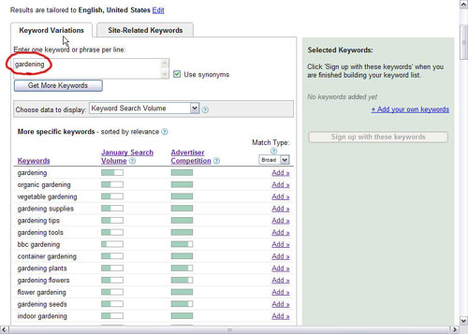

At the very top of the graphic you’ll see two “tabs,” labeled Keyword Variations and Site-Related Keywords. We’ll use the Keyword Variations tab.

Enter your Primary Keyword into the box, tick the “Use Synonyms” box and select “Keyword Search Volume” from the drop-down box. Once that’s done, click the [Get More Keywords] button and the search will begin.

You will be given a long list of keyword phrases relating to your Primary Keyword and next to each will be two graphic bars. The left-hand bar will give you an idea of the search volume and the right-hand bar will give you a heads-up on how heavy the competition is for that keyword through Google’s Adwords program. This is really good information, make a note of it!

The keywords to pay special attention to are those that get decent search volume but have only moderate competition. Granted, that doesn’t happen often but it does happen.

Modest, One-Time Fee Method:

Now, I realize the word “modest” is rather subjective, but the tool I’m about to show you is extremely powerful, and costs less than some membership sites charge for a year of service.

The tool is Keyword Elite, and it’s so feature-packed that I can only scratch the surface here with what it can do. If you visit the site you’ll learn more about what it can do, as they offer five screen-capture videos explaining the features.

The screen-shot below shows the main screen.

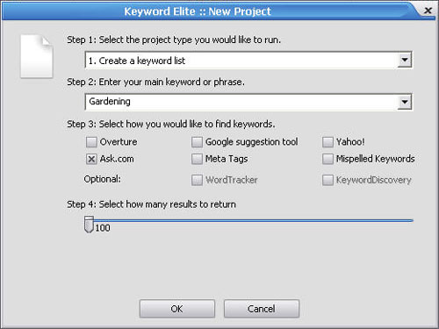

When you open Keyword Elite, you’ll see this screen. There are five different “projects” that Keyword Elite will perform but I’m only going to touch on the first one which is “Create a keyword list.”

Enter your Primary Keyword into the appropriate box, choose which search engines you’d like to get your results from, and choose how many keywords you’d like Keyword Elite to return. You can choose as little as 100 or as many as 10,000!

I’ve typed in Gardening, selected Ask.com as the search engine and asked for a list of 100 keywords.

Here’s what Keyword Elite returned.

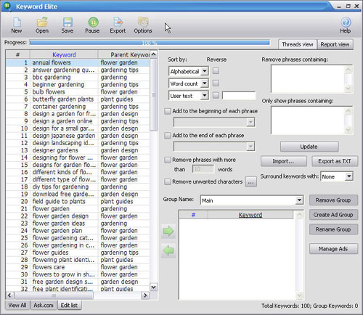

Alright, Keyword Elite has worked its magic and has returned 100 keyword phrases to me based on our Primary Keyword, Gardening. In the left hand side of the screen you’ll see two columns, Keyword and Parent Keyword.
This is really slick as most keyword tools merely give you keyword phrases which contain your Primary Keyword. Keyword Elite is also returning phrases which are related to Gardening, but don’t necessarily contain “gardening” in the keyword phrase.

For instance, the first result has a Parent Keyword of “flower garden” but the associated Keyword is “annual flowers.” This is a complimentary phrase frequently associated to Gardening and is what’s known as an LSI (Latent Semantic Indexing) keyword phrase. (More about LSI in a bit)

Another great feature of Keyword Elite is that is lets you filter your lists quickly and then copy them as a .txt (text) file. This way, you won’t have to copy any of them by hand.

You can learn more at: http://www.KeywordElite.com

My Favorite Monthly Membership Site For Keyword Research:

I have memberships with two other keyword service providers but of the three, NicheBOT.com is my favorite. I’ve only been using the service for a short time so I’m still learning the ropes, but it’s incredibly robust and easy to use.

The cost for the “lite” version, which is the one I have, is under ten bucks a month and even includes a 1-click LSI keyword tool. I know, I know, I promised to explain LSI and I will… just not yet.

The next page will give you a look at the log-in screen for NicheBOT.com

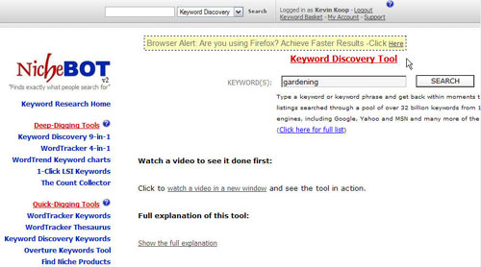

I’ve logged into my account and have chosen to use the Keyword Discovery Tool to conduct the search. You’ll never be at a loss for keywords as they offer more options than you can shake a stick at.

I entered Gardening in the search box and clicked [Search]. The next screen-shot will show you the results.

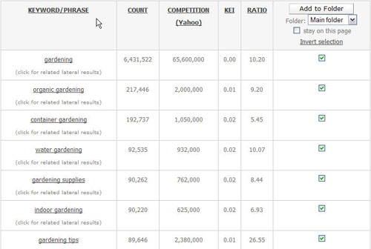
I only pay attention to the first three columns… Keyword/Phrase, Count and Competition. The Keyword/Phrase column is self-explanatory; it gives you a list of keyword phrases.

The Count column gives you an idea of search volume. I don’t care about the specific number, I only reference it against the other keywords to find out which is more heavily searched. The higher the number, the more searches.

The Competition column tells you how many websites are targeting that keyword phrase by placing it in the Title Tag of their website. The higher the number, the more competition you’ll have in getting high search engine placement.

Alright, I promised to discuss LSI (Latent Semantic Indexing) so here we go:

Note: LSI is a complex subject, but I’ll do my best to explain it. Basically, the search engines check your web page (or articles) for your obvious keywords and then look to find other keywords/phrases that are typically linked. Huh?

Let’s say we write an article about Gardening Tips. The search engines will expect keywords which contain “gardening” in them like: “gardening tools,” “gardening advice,” etc. but they will also expect to find words commonly associated with gardening; say “soil” for instance. If they don’t find these LSI phrases the search engines may believe you’re “keyword stuffing.”

Keyword stuffing occurs whenever a webmaster tries to trick the search engines by overloading a page with a repetitive keyword phrase. It may work for a bit, but the search engines are getting smarter all the time and they don’t like it!

To learn more about LSI, you can download the “LSI Report” (for free) at:
FREE LSI Report

To take a tour of NicheBOT’s service and get a 14 day trial for $1 go to:
http://www.NicheBOT.com

Now, we’ve covered a lot of ground here so I’ll try to break down your objective and simplify it as much as possible. You are looking for keywords that have decent search volume (don’t get too hung up on an exact number), have “reasonable” competition and make sense for the product or service you plan to promote. In addition to this, it’s good to gather LSI keywords that can be sprinkled throughout your article content.

Step #2: Choose Your Article Format: 3 Proven Types

I think it’s important to know which “article format” you plan to use even before you settle on the content you’ll write about. If you know which format you plan on using, you’ll gather your research material a whole lot faster!

While there is certainly nothing wrong with “essay” type articles, the following three formats have been proven to be effective and are probably the easiest for a novice to follow.

Format #1: Tips Articles

In this format, you simply state the topic your tips will be about and then break them down for the reader chronologically.

5 Gardening Tips To Improve Your Herb Garden

If you’re enthralled with herb gardening, as I am, you’re no doubt looking for ways to improve the health and overall quality of your plants. If that’s the case, you’re going to love the following 5 tips:

- Tip #1 is explained here and it should be
the most tantalizing tip you have to offer.

- Tips #2-5 continue in the same manner.

*Include a conclusion or a summary of the tips you’ve offered at the end; and you’ve got yourself an article!

Format #2: Review of a Product or Service

This format is self-explanatory. You simply provide a review of a product or service that is related to your website. This format is the most obvious for affiliate marketing as you can review the product you’re marketing and then offer the reader the opportunity to learn more about it by visiting your site.
Garden Widget Reviewed: Does It Really Work?

If you’re into gardening, as I am, you’ve probably heard of the Garden Widget which has just been released by XYZ Company. Even though I was a bit skeptical of the claims being made, I decided to buy the Garden Widget and put it to the test. Here’s what I found:

*Make sure to give an honest review and point out a couple of the minor flaws of the product or service, as your article will be better received.

Format #3: Frequently Asked Questions (FAQ) Articles

This is an extremely easy format to research and write. Check out the sales page (of the product to be promoted) to glean what questions and answers the copywriter has included in the sales letter.

Good copywriters will almost always address the most important objections (questions) in the mind of their target market and will provide answers which overcome them.

If you still want more questions, go to the forums and surf around for 15-30 minutes. You’ll most likely get the “ammunition” you need to write several FAQ type articles on the subject.

Garden Widget: Top 5 FAQs Answered

As an avid gardener, and an experienced user of the Garden Widget, I’m frequently asked questions about the use and quality of this tool. Here are the top five questions asked:

1. Does the Garden Widget really do XYZ, as it says it does?

The Answer to question #1 goes here. Remember to try to write in a somewhat “unbiased” tone. Don’t say… “Yeah, the Garden Widget does XYZ great and a whole lot more! As a matter of fact, I would have paid three times what they asked me for this little honey!!!”

You get the drift; give honest insight… not hype! If you do, you’ll get clicks!

Now then, all three formats work really well, but I’m going to choose the “tips” format to continue to illustrate the “Article Domination Method.”

In the next section, we’ll do some quick research and gather the information we need to write our article but before we do, we need to have a “rough” idea of what our topic will be.

At this point, we know the article will be about Gardening and will be in the “tips” format. “Gardening Tips,” however, is much too broad so we need to hone in a bit. Going back to our keyword research, two keyword phrases jump out at me… Container Gardening and Gardening Tips.

If we combine all three, we get “Container Gardening Tips” and that’s what we’ll use when doing our research.

Step #3: 5 Quick, Creative Techniques To Get Article Content

Before I begin, you’ll quickly notice a trend when looking at the tips below as they all have something in common… Swiping! Ask any good copywriter how they go about writing a sales letter or ad and they’ll tell you… First, I go through my “swipe file” to get ideas.

This is an important concept and we’re going to use it in our article writing as well. There is no need to start with a blank piece of paper or a blank document in Word. Using the ideas, below, you’ll find tons of quality content you can swipe from!

- Magazines. If there is a magazine (or several) available for your niche this is a great place to start. Magazines are expensive to produce and distribute, so the editors go to great lengths to provide interesting articles for the readers. After all, they need readers to sell ad space!

Tip A. Go to: http://www.Magazines.com to find a huge variety of mags.

Tip B. Visit your local bookstore and either skim the magazines for information (bring your notepad) or buy some and take them home to really get into them.

Tip C. In addition to researching the articles, don’t forget to look through the ads. The ads are where the money is, if you find out what products are being sold, you’ll also learn what problems those products seek to solve… this is golden.

Tip D. If you plan to stay in the niche a while, I’d suggest getting a subscription to one of the magazines that is heavily-circulated. Subscribers typically receive their issues before they hit the newsstand so you can research the issue, and write (& submit) a few complimentary articles before the magazines are even available to the general public.

Tip E. For many niches, there are trade magazines available. These are invaluable for a number of reasons. They’re generally offered for free, to professionals involved in the niche (you) and they contain insight not generally discussed with the public. Basically, you just review the articles, rework them in your own “voice,” throw in your own opinion and voila… you have an article that’s ready to go.

Take a look at the screen-shot below

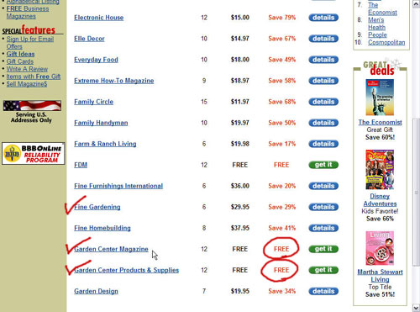

This is a screen-shot of the Magazines.com website. Basically, I went to the site and searched for magazines related to gardening. The results you see are related to the Home & Gardening category.

If you look at the magazines I’ve check-marked, you’ll find Fine Gardening, Garden Center Magazine and Garden Center Products & Supplies.

Fine Gardening is an upscale magazine which is targeted at the affluent hobbyist, and we’ll be using it to get ideas and gain insight into the gardening market. The other two magazines are trade magazines and as you can see, they’re available for Free.

This research goes really fast and the information available will give you more ideas than you thought possible.

- Perform a search on http://www.EzineArticles.com

EzineArticles.com is one of my favorite article directory sites. Besides being a place you’ll want to submit to, they are also great for research.

Once you’re on the site, scroll down the left-hand column and find the area which says, “Search Ezine Articles.” Enter your keyword phrase and choose “Search Article Keywords” in the drop-down box.

After you’ve clicked [Search] a long list of articles that contain your keyword phrase will be delivered to you. There is much to learn here… What styles of articles are most common? Are they reviews, tips, how-to’s, etc.?

What keyword phrases keep popping up, over-and-over?

Where do the links from the resource box go and what do the sites they go to offer?

I could go on for ever, just realize this is a goldmine that you should take advantage of. Print out 5-10 articles you really like and highlight the specific things you liked about them. You may have loved the Title in one article, thought the Bio was great in another and really enjoyed the website linked in yet another. Anyway, store these away and take good notes as they’ll make your life easier in the future.

- Perform a simple search, say on Google. Yeah, this is basic but its still effective, so stick with me.

Click on the top 3-5 websites that are delivered to you in the organic search results and spend a few minutes on each. I’d suggest printing out the most relevant pages and adding them to your swipe file.

- Search Yahoo Groups. While there are many forums on the internet, Yahoo groups are my favorite for this type of research. You’ll find Yahoo Groups at http://groups.yahoo.com

When you’re there, enter your keyword and search for groups. I searched for groups on “gardening” and found there were 12 different sub-categories and a total of 2,510 groups related to gardening.

As you scroll down you’ll notice a few things. The number of members is listed for each group and you’ll be able to determine whether the group is open to the “public” or if it is a “membership required” forum.

Search through a few of the Public forums and try to get a feel for recurring themes. What are they into? What problems do they have? What products do they mention? Keep track of the “hot topics.”

Note: Surfing forums can be somewhat addictive. Give yourself a time limit and then stick to it. Otherwise, you may find you waste a lot of time.

- PLR (Private Label Rights) Articles. It seems PLR articles are all the rage these days. Basically, you can buy a big package of articles that you are free to do just about anything with. You can submit them as is and claim authorship, you can change them any way you want, etc. etc.

However, you should be aware of the downsides of PLR articles. Some packages include well-written articles while others are complete junk!

Most marketers buy these packages with the intention to submit them as is, after all, they’re LAZY! This is worthless at best and can even be a detriment. The search engines look for “duplicate content” and can tell when folks are basically “spamming” with articles.

Even with these drawbacks, PLR articles can be quite useful. They’re great for getting ideas, and if you get 3-5 PLR articles that are closely related, you can pick a little from each article and customize it into one article that will be original content.

Here are some PLR sources:

PLR articles are so hot these days it’s quite easy to find them. If you search for “PLR articles” on Google you’ll be surfing pages for days!

Source #1: http://www.plrpro.com
I’m not a member of this site but I hear great things about it. I believe they limit their membership to 200 people, and provide over 400 articles per month! You’d have to be serious though, as they charge something like $97 a month.

Source #2: http://www.contentgoldmine.com
Again, I’m not a member of this site, but it’s run by Ryan Deiss, and if you’re not familiar with him, you should be. I met Ryan while on a Caribbean Cruise which was sponsored by Internet Marketer Jim Edwards. Besides being a brilliant marketer, Ryan is a genuinely nice guy.

Content Gold Mine isn’t as exclusive as PLRpro, as their membership cap is 1,500 people but… They offer a very unique service. For under $30 a month you get tons of keyword-rich PLR articles, keyword lists which support each article, and a 5-part Mini-course you can use in your autoresponder series. If you’re interested, you’d better hurry as there are less than 200 memberships still available (last time I checked).

Note: I am a member or Ryan’s Nicheology.com website, which I love, but unfortunately, membership is currently closed.

Pro Tip: Before submitting a PLR article you’ve altered, you should make sure the search engines see it as “original content.” It’s easy (& cheap) to do and I highly recommend doing this before you submit your article.

Now that I think about it, this would also be wise to do if you were outsourcing your articles to a ghostwriter. You want to make sure your articles are “original” to avoid any legal hassles or search engine penalties.

First, create a new page in your HTML editor of choice, paste in your article’s text and upload it to your site. Name your page something like “article1.html.”

Your article URL would be http://www.XYZDomain.com/article1.html

Next, go to http://www.copyscape.com You’ll find a box to paste your URL into, and a button to start the search. Copyscape will go out on the web and will let you know if it found any duplicate content. If it does, it will show you the web pages it found and will also tell you how many words it found in common with your page.

Personally, I won’t submit an article until Copyscape is unable to find a match. If it does find a match, I revise my article and then start the process over.

Copyscape’s service is free for a small amount of searches and then 5 cents for each search thereafter. It’s a no-brainer!

Super Secret Tip: Wait a week or two, after your articles have been submitted and then search for them on CopyScape. This will tell you how many sites are displaying your articles and will allow you to get a look at the sites interested in your writing. Who knows, you just might find a JV partner this way.

Step #4: How To Write A “Killer” Article Title

When writing your article title you have to remember your objectives. Your first objective is to be found in the search engines. The second is to entice web surfers to click on your listing, read your article and then click on the link you’ve supplied in your resource box.

In order to get found in the search engines, your Keyword Phrase needs to be included in your title, and be repeated every so often, in your article body. (More on this to come)

In order to get web surfers to click, your titles have to be clear in their benefits and be interesting to read. If I title my article “Gardening,” I’m not likely to get a whole lot of clicks (i.e. Traffic).

PRO-Tip: Search engines will give more importance to your articles if your Primary Keyword is found within the first 3-4 words of your article’s title.

Since we’ve decided to write about “Container Gardening Tips,” here are some variations of titles we could use:

- Container Gardening Tips
- Tips For Container Gardening
- Container Gardening Tips For The Novice Gardener
- Container Gardening Tips: 5 Surefire Techniques

Alright, let’s evaluate these. #1 would work but the title may not be compelling enough to “get the click.”

#2 reads fine, but it changes the order of the keyword phrase and will probably reduce our chances of being found. The great thing about the title, “Container Gardening Tips” is that we can be found by someone looking for “container gardening,” “gardening,” “gardening tips,” and “container gardening tips.” This is important, and we don’t want to mess this up by rearranging the keyword phrase.

#3 is fine but it reduces our chances of getting clicks by including the word “novice.” If a web surfer found our article, but considered themselves “beyond” novice, they might just pass us over.

#4 is the clear winner for a number of reasons. It keeps our keyword phrase in the proper order and puts it in the beginning of our title. It includes a specific number of tips and a tantalizing piece of copy which reads “surefire techniques.”

If someone who is interested in Container Gardening sees our article listing, they are likely to click, and that is our goal… No, our mission!

PRO-Tip: Including a specific amount of tips in the article’s title will definitely improve our chances of getting traffic. Odd numbers, generally 3, 5 or 7 work best (or Top 10) and I suggest you include the numerical symbol rather than writing out the number (use 5, not Five).

Step #5: How To Write A Quality, Keyword Rich Article

This is where many marketers “freeze.” As soon as you tell them they have to write articles, they run for the hills. Don’t panic! This is going to be a whole lot easier than you might have imagined.

I’m going to show you the “free” method and then show you an inexpensive tool that makes the process fast and easy! I’ll also cover the basics of outsourcing your article writing and offer tips to save you money in the process.

In the last section, we chose “Container Gardening Tips: 5 Surefire Techniques” as the title for our article. With that in mind, we just need five solid tips to offer the person interested in Container Gardening.

Free Method:

Really, we’ve already collected “chunks” of content from the sources listed in Step #3, but I’ll give you a summary of how I approach this.

First, I go to EzineArticles.com and search for articles about Container Gardening. I would spend about 10 minutes skimming some articles and copying the chunks of text I found interesting. I would copy content that seemed to contain “tips” on container gardening as well as quality “introductions” and “summaries.”

I’d probably gather 10 “tips” even though I only intend to put five in my article. I’d paste them into Notepad or Word for future reference.

Next, I’d visit a magazine site, in this case, FineGardening.com and search there as well. I’d go through the same process as before, and save any quality “copy chunks” to my document.

With this accomplished, we’ll have more than enough information to write a great article. As a matter of fact, we’ll probably have enough to write a second article, which will contain some different tips!

Here are some chunks I swiped. I’ve highlighted the sections that I particularly like.

Chunk #1:

The first step to container flower gardening is of course deciding the type of container to use. In order to determine which container you want to use, you need to decide where you are going to hang your container flower garden. Common types includes pots, hanging basket and window box.

You then need to decide the material of the flower container. Common types include ceramic pots which are easily available and wooden barrels. Other types include plastic or terra cotta flower containers.

Regardless of which type of container you choose, make sure there is sufficient drainage to avoid over-watering. The
correct flower container can make it a lot simpler and easier to grow flower gardens.

Chunk #2:

Beginners may want to focus on drought tolerant and easy growing plants. Your local nursery can help you with these
selections based on plants that work best for your climate and zone hardiness. Keep it simple, having one plant in a
container is perfectly acceptable. Combine plants that have similar needs and equal strength.

Aggressive plants can easily take over a container and your smaller plantings may get lost. A simple formula for putting multiple plants within a container is at least 1 tall, 1 filler, and one tailing plant. Check your plant daily, finger gage for watering needs, deadhead, weed, and pinch back when necessary.

Chunk #3:

There is a tendency to think of container plantings as only an accent for the patio, front door, or window, but
containers offer gardeners so much more. Container gardens allow us to experiment with different plant combinations
without planting a flower bed, or create a landscape where it would otherwise be impossible -- say, on the 37th floor
of a New York high rise. And if we'd rather have those plants next to these plants, well, all we have to do is heft a pot or two, and in a minute, we've rearranged the garden.

I’m sure you can see where I’m headed. I simply highlight passages I like and ones I think will flow together. Then, I simply arrange them and switch them up a bit to create a quality, unique article.

To keep this brief, I’ll only include three tips as this will be more than enough for you to get the idea.

Container Gardening Tips: 5 Surefire Techniques

Container gardening is all the rage these days and for good reason. It offers all of the benefits of traditional gardening; relaxation, exercise and the enhanced beauty only nature can bring, and it’s easier to learn.

If you’ve been looking to start a container garden, then you’re going to love these five container gardening tips.

- There are many choices of containers suitable to container gardening. These include free-standing pots, hanging baskets and the traditional window box to name a few.

Whichever container you choose, make sure it allows for sufficient drainage to avoid over-watering. Choosing the correct container will make your life easier, and will help your plants thrive.

- Those new to container gardening may want to start with easy growing plants that are drought tolerant. Your local nursery will be glad to help you make selections based on plants that work best for your climate.

At first, keep it simple. Having one plant in a container is perfectly acceptable.

- Get creative with your container placement. While many only use them as an accent for the patio, front door, or window, containers offer gardeners so much more.

A new trend, in container gardening, is to use them to line, or create, a pathway. With taller plants, they can also be used to enhance privacy, creating a visual barrier. There are no right and wrongs, you are only limited by your imagination.

Alright, I think you get the general idea. I basically used the swiped “content chunks,” made some changes, added a few transitions, and voila… We’ve got ourselves an article.

I pasted the body text into NoteTab Light, my favorite text editor (more on this to come) and found the word count to be 231 words. After adding two more tips and a conclusion, we’d probably end up around 470-500 words and this is just fine.

Writing Articles With “Instant Article Wizard” (IAW) Software:

This tool is a godsend for novice and advanced article writers alike! After you’ve written a couple of article’s with it, you’ll be able to crank out an article in about 30 minutes, maybe faster.
There are 8 steps, and IAW walks you through each one, step-by-step.

- Choose Topic – In this screen you enter the Main Topic of your article and can include up to 3 Subtopics as well.
- Collect Research – IAW will crawl the internet and will give you a large amount of “short copy chunks” from a variety of web sites. You don’t have to be worried about “duplicate content” as it only takes a sentence or two at the most, from each website.
- Introduction – Double-clicking any “copy chunk” will automatically transfer the text into you “keeper” area. Copy “chunks” you think will fit nicely into your article’s introduction. The “chunks” can be re-arranged in a logical order after you have them in the “keeper” area.
- Subtopic 1 – Simply double-click the “chunks” you’d like to keep.
- Subtopic 2 – Same as Subtopic 1
- Subtopic 3 – Same as Subtopic 1
- Conclusion – Double-click the “chunks” relevant to the conclusion.
- Modify Article – IAW will copy your “keeper text” into the window and let you modify it. When you’re done, copy the text to the clipboard.

Here are some screen-shots of IAW for further clarification:
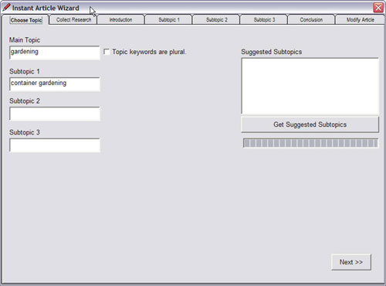
In the “Choose Topic” screen, you enter the main topic of your article and can enter up to three Subtopics as well. If you’d like IAW to recommend some Subtopics, click the [Get Suggested Subtopics] button.
Once you’ve entered in this information, just click the [Next] button. IAW will take you to the next step and being collecting research.

Once the research is complete, in about 1-3 minutes, click the [Next] button to move to the Introduction section. (shown below)

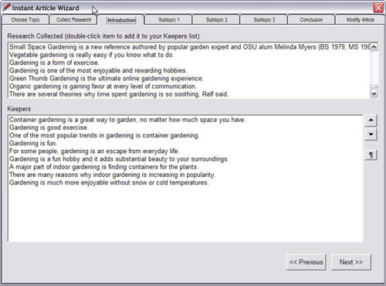

All the research on the topic can be found in the box at the top of the screen. Double-clicking on any “copy chunk” will automatically transfer that bit of text to the “Keepers” box. After you’ve selected your “copy chunks” you can re-arrange them using the Up-and-Down arrows on the right hand side of the screen. You can also enter a paragraph break if you’ve made more than one paragraph out of the text. Click [Next] to continue.

The sections “Subtopic 1,” “Subtopic 2,” “Subtopic 3,” and “Conclusion” work exactly like the “Introduction” section. Just copy the “chunks” of text you like to move to the “Keepers” box and click [Next] to continue.
When you arrive at the last section, “Modify Article,” IAW will paste the text you’ve collected/arranged into the large window. You can choose to “Rebuild Article” or copy it to the clipboard. When you’re finished, copy the text to the clipboard. Shown in the screen-shot on the next page.
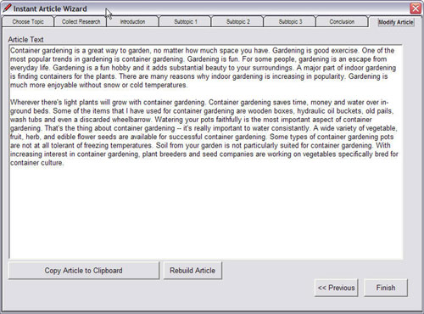

In order to produce a quality article, you’ll want to spend a few minutes cleaning up the text and improving the transitions, but this is a very quick way to gather relevant information and produce an article. Jonathan Leger, the creator of Instant Article Wizard, was challenged to write an article in under 15 minutes on a topic he knew nothing about.

To see the results of the challenge, and to watch Jonathan create the article step-by-step, click here: http://www.InstantArticleWizard.com

Outsourcing Your Article Writing:

If you’re still not convinced you can write articles yourself, you may want to consider outsourcing. Most everyone has heard of Elance.com and it certainly is a place to consider, but I’ll give you a couple more resources and some tips that should help you save some money.

Resource #1:

http://www.Elance.com Elance offers a lot more than writing services. You can find graphic designers, web designers, software programmers and a whole lot more. The great thing about Elance is that it’s free to register and you can get a free quote on your project without being obligated to move forward.

If you decide to use Elance to hire an article writer, here are some tips:

- Never do business with any provider unless their feedback is stellar! Many people won’t leave negative feedback for a provider even if their service stunk. While it may not seem “fair,” I won’t do business with anyone that has less than a perfect record on Elance.
- Submit a request for one article and award the same project to 2-3 providers. That way, you can choose to do business with the person you were most happy with in the future. In fact, some providers are willing to do business “outside” of Elance, so you might just be able to work directly with the provider, and save some time and money in the process.
- You can submit a short report, an ebook or an audio recording you’ve made and ask providers to bid on turning the work into 5, 10 or even 15 articles. Many times, this will save you a good deal of money as you may get a bid of $90-110 for a request of 10 articles when it probably would cost you $15 or more for a single article.

Resource #2:

http://www.HelpMeRhondaMarketing.com This site is owned by Rhonda Ryder. Rhonda is a talented writer and a personal friend of mine. In addition to article writing, Rhonda offers just about every writing service under the sun including the creation of compelling sales letters. If you decide to go with her, make sure to tell her I sent you.

Resource #3:

http://www.CraigsList.org You’re probably familiar with this free classified site but you may not have known that it can be a real gem for internet marketers.

Generally, you’ll find better pricing here than on Elance, but there are some issues to be aware of. First, it can take longer to find someone because each city or region has a separate listings database.

Second, there is no feedback or protection system so “buyer beware” is the rule of the day. The good news is, you get to read their classified listing and if it stinks… run for the hills.

When you go to the site, select an area and find the “Services” section. Click the “Services” link and enter “article” into the search box. I just did this and found many people to choose from. Here’s an example of an ad I found:

“Need to build content on your website in a hurry? Have specific requirements that need to be followed?
Our team is a detail oriented professional writing team, that is able to produce large amount of articles in a short amount of time. We provide articles of the highest quality, all original, and copyscape proof.
We hope to do business with you soon.”

Resource #4:

http://www.WeSubmitArticles.com This site provides a “turn-key” solution. They will write the articles for you and submit them to any number of article directories you choose. They certainly aren’t cheap, but they offer a valuable service for anyone who wants to gain the benefits of Article Marketing without having to do any work.

Checking The Keyword Density Of Your Article:

Now, before we move on to the next section, I want to discuss the issue of Keyword Density. It’s important our articles are “keyword rich” so the search engines will know to “serve up” our listings whenever someone enters one of our keyword phrases in the search engines.

Pro Tip: Most SEOs (Search Engine Optimizers) will say that your “keyword density” (The ratio of how many times your keyword appears relative to the overall length of the text) should be about 1-3%.

Great… how do I go about doing that you ask? Simple, just go to http://www.live-keyword-analysis.com This site will check your keyword density for free. Type in your primary keyword and paste your article body into the large box. Click the [Update] button and the site will tell you the keyword density for your article.

Note: I checked the body text (for our Container Gardening Tips article) using Live-Keyword-Analysis.com and found the keyword density was 2.8%. This is great and will definitely help our article get noticed by the search engines.

Step #6: How To Craft A Compelling Resource Box

It’s funny; many article writers spend lots of time (or money) on their body content and then fail miserably with their resource box. Let’s be clear, the main reason we’re writing articles is to get “targeted visitors” to read our articles AND then click the links we’ve provided in our resource box.

If we’re not bringing traffic with our articles, we might as well just buy PPC advertising!

The good news is, writing a compelling resource box is really easy. I’m going to show you several examples of quality resource boxes and then I’ll break down the individual elements that make them successful.

Example #1:

Matt Bacak became a "#1 Best Selling Author" in just a few short hours. This recent Entrepreneur Magazine’s e-Biz radio show host is turning Authors, Speakers, and Experts into Overnight Success Stories. Discover The Secrets To Unleash The Powerful Promoter In You! Sign up for Matt Bacak's Promoting Tips Ezine ($100 value) by visiting his website at http://www.powerfulpromoter.com

Example #2:

Jim Edwards is a syndicated newspaper columnist and the co-author of an amazing new ebook that will teach you how to use free articles to quickly drive thousands of targeted visitors to your website, affiliate links, or blogs... Need MORE TRAFFIC to your website or affiliate links? "Turn Words Into Traffic" reveals the secrets for driving Thousands of NEW visitors to your website or affiliate links... without spending a dime on advertising! Click Here => http://www.turnwordsintotraffic.com

Example #3:
Jonathan Leger is the creator of the first commercial AdSense Tracker script packages available, which has
grown into the widely-popular product set, AdSenseGold.com
The full 5 part SEO tutorial is also available in an ebook which you can download from:
http://www.adsensegold.com/downloads/AdSenseSEO.pdf
Example #4:
ABOUT THE AUTHOR: Derek Gehl specializes in teaching real people how to start profitable Internet businesses that make $100,000 to $2.5 Million (or more) per year. To get instant access to all his most profitable marketing campaigns, strategies, tools, and resources that he's used to grow $25 into over $40 Million in online sales, visit:
http://www.marketingtips.com/tipsltr.html/882197
Example #5:

Yanik Silver is recognized as the leading expert on creating automatic, moneymaking websites...and he still doesn't know how to put up a website. He is the author, co-author or creator of several best-selling online marketing books and tools. His newest resource, for making this year your best yet, can be found here-
http://www.surefiremarketing.com
While there are some stylistic differences, each of these resource boxes has several things in common.

- They are written in the “third-person.” While it may seem silly, readers find them to be much more credible than those written in the “first-person.” You will get less clicks if your resource box says, “I am an avid container gardener who enjoys…”
- They all contain elements which speak of their expertise. Statements such as, “#1 Best-Selling Author,” “syndicated newspaper columnist,” “recognized as the leading expert on…”, etc.
- This is a Biggie! They ALL include a clear CALL TO ACTION! Some are low-key, like, “visit” or “can be found here,” while others are a little more direct, like Jim Edwards’ “Click here =>.”

Here’s an easy template to follow:

- Introduce author in “third-person.”
- Make a statement to increase credibility.
- List the benefits the reader will receive if they visit your site.
- Give them a call to action.

PRO-Tips:

- Send your visitors to a squeezepage or offer a free download. If you offer a free download, as in the case of Jonathan Leger’s resource box, you can include links to your product(s), affiliate programs, sites with Adsense, or a link to your main squeezepage.
- If the article directory allows, include an “anchor text” link.
- Use tracking links in your resource boxes so you can track your traffic. (You’ll find my favorite two link management tools in the Valuable Resources section).

Note: Creating “anchor text” links requires HTML coding. If you’re unsure how to do this; check out the example, below:

<a href="http://www.XYZDomain.com" title="Gardening">Gardening</a>

This piece of code includes 3 elements… the URL you’re sending traffic to, the “alt-text” or title of your link, and the “anchor text” which is displayed to your reader.
Step #7: Locate Article Submission Outlets

There are many outlets looking for quality content in the form of articles. It’s a “win-win” situation really… they need content, and you’d like exposure, targeted website traffic and a huge influx of “backlinks” to your site.

By submitting your articles, you agree to let anyone use them in their ezines, blogs or on their websites as long as they include your resource box. Here are some examples of outlets you can submit to:

- Article Directories
- Ezine Publishers
- Blog Publishers
- Website Publishers

The most obvious outlet for your articles is the Article Directory sites. The large majority of these will publish your articles for free and the better ones are considered “authority sites” by the search engines.

Some of the article directories have large distribution networks and will submit your articles to a number of other outlets on your behalf. This is fantastic and exponentially increases your article’s exposure.

In addition to the Article Directory sites, you can submit your articles directly to Ezine Publishers, Blog Publishers and Website Publishers who supply content targeted to your market. It takes a little more work to find these outlets, but the effort can really pay off.

If you want to expand your article’s “reach” without having to do all the “leg- work,” consider submitting your articles to: http://www.directoryofezines.com
This is a paid membership site that will submit your articles to relevant Ezine Publishers on your behalf.

Now then, to be completely forthcoming, I only submit my articles to the article directories and I’ll tell you why. While submitting to the other outlets is beneficial, it is also time-consuming, or costly.

Personally, I have found that if I’m submitting quality articles to the better article directories, my articles will find their way into Ezines, Blogs and Websites. The publishers of these frequently search for quality articles to publish, doing the “leg-work” for me. Note: You will find a detailed list of my favorite article directories following Step #9.

Step #8: How To Efficiently Submit Your Articles

While article directories allow you to submit your articles directly to their site, this sucks up a lot of time that could be much better spent. I use an inexpensive software program called “Article Submitter” to help me submit my articles but you could choose to outsource this as well.

When I started writing and submitting articles, I was using a program called Article Assistance. I later found that Article Assistance and Article Submitter were the same piece of software just with different graphics.

I purchased the Resell Rights to Article Submitter and am making it available to purchasers of the Article Domination Method (you) for only $17. Many others are selling this software for $37-47 so if you need article submission software, you’ll save yourself some money.

Using it, I can submit an article to twenty-five different directories in 30 minutes or less. Yes, there are hundreds of directories available, but I generally only submit to the 25-35 directories I really like.

I’ll show you what Article Submitter looks like and give you a quick rundown of how it’s used beginning on the next page:

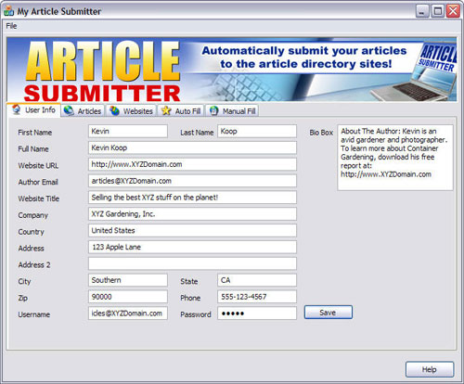

Step #1: When you first run the program, you’ll enter your personal information into the “User Info” screen. This will be saved, so you’ll only have to do it once!

PRO-Tip: Before creating your free accounts with the article directories, create a special email address. For example, you could create an email address like: articles@XYZDomain.com

This way, you can keep all the correspondence you’ll receive from the Article Directory editors organized in one place.

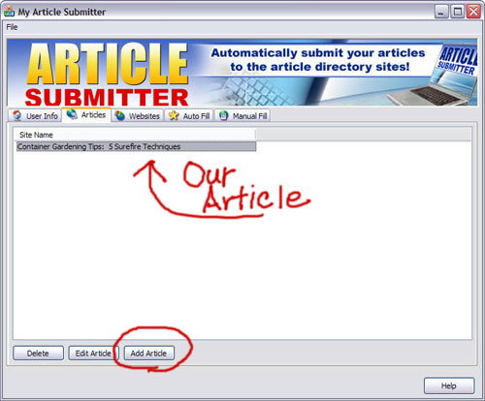

Step #2: In this screen, there are three options. You can Delete or Edit an article you’ve already loaded, or Add a new article. After you’ve saved your article in Article Submitter, it’s title will appear in the top area and will remain there until you decide you no longer need it.

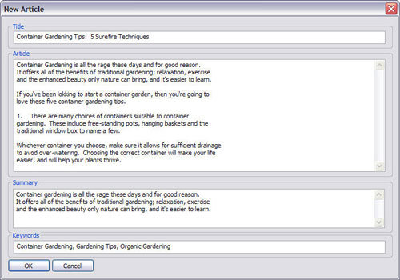

Step #3: This is the screen where new articles are entered. You enter the title, the article body, a paragraph summarizing the article and keyword phrases related to your article.

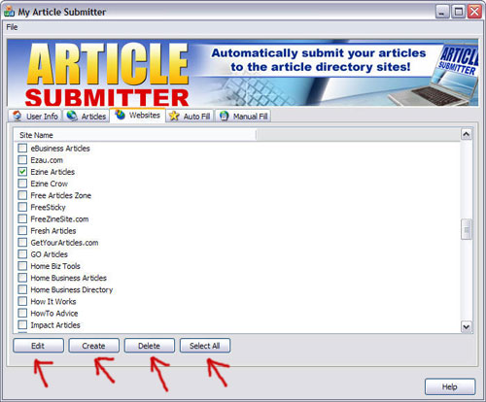

Step #4: After you’ve saved your article(s), you choose which directories to submit to. You can also Edit the details for a directory if their login URL has changed, Add a new directory to submit to (using the Create button), Delete a directory, or choose to Select All directories with one-click.

When this step is done, you’re ready to start submitting.

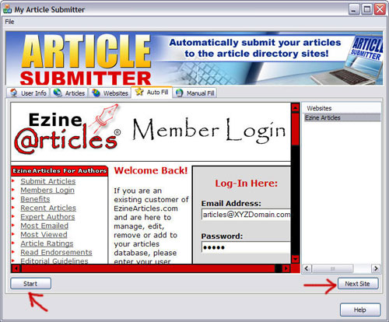

Step #5: After clicking the [Start] button, the software automatically opens the log-in screen for your first directory and enters your log-in information. After the log-in is complete, it automatically populates the necessary fields so you can submit the article.

This happens really fast, I’d estimate it takes about 1 minute to submit to each directory. After successful submission, you click the [Next Site] button to log-in to the next directory.

To get Article Submitter, click the link below:
http://www.ArticleDomination.com/ArticleSubmitter

Now then, if you’d rather outsource your article submissions, you have a couple of options:

You could hire a responsible “youngster” and teach them how to use your article submission software, or use a service to do your submissions for you. Both methods will help you free up your time and we’ll evaluate each.
Hiring a “youngster,” especially if the “youngster” is your child, might be a great way to keep the business “in the family,” but it isn’t as cost-effective as you might think. For example, if you paid just $5 per hour to have your articles submitted, you’d pay $20 per month to have just 4 articles submitted to approximately 30 article directories.

Quite honestly, 4 articles per month is about the absolute minimum I’d recommend. At this rate, you’d be paying about $240 per year for article submission.

Another way to go is with an online article submission service. One well-respected service is ArticleMarketer.com The service isn’t “cheap,” but is an awesome value for anyone routinely submitting articles.

As I write this, a year membership to Article Marketer costs $200 and they’re offering a second year for “free.” This is a much better value than hiring a “youngster” and you can submit an unlimited amount of articles.

Basically, you upload your article information to Article Marketer once, and they distribute your article to a dizzying amount of sources through their “One-Touch” process.

If you’d like to learn how to take Article Marketer for a Free test-drive, visit:
http://www.ArticleMarketer.com

Newsflash: Brad Callen, the creator of Keyword Elite and SEO Elite, has just announced that he’s upgraded his SEO Elite software program. SEO Elite will now have an article submission feature similar to Article Submitter.

If you don’t already have article submission software, this is worth looking into. SEO Elite offers a multitude of features to help improve your site’s search engine rankings and with the added article submission feature, this may just be what you’re looking for. To learn more, visit:
http://www.SEOElite.com

Step #9: Step-By-Step Marketing Plan For Dominating Your Niche

While article writing is not that difficult, it still takes time and effort. Therefore, it is imperative that you squeeze every ounce of benefit out of each and every article you write.

You may not have the current capability to capitalize on every step mentioned, but if you concentrate on those you do, your articles will spread far-and-wide.

- Write 10 articles (or outsource) and get them ready to submit
- Upload your articles to your own site. Note: Even on squeezepages, I think it’s important to have a link to your articles. Include a small link, entitled “Articles” on the very bottom of your page.
This way, you won’t distract your squeezepage visitors, but if they find the link they can learn more about you through your article writing. It’s a good idea to include an Autoresponder Form on each article page to catch visitors who might have come in through the “back door.”

Your URL might be: http://www.XYZDomain.com/articles/article1.html or something similar.

PRO-Tip: The search engines love this as they like to see sites with quality content and also like to see a site “grow.”
- If you have affiliates, send them two articles and let them mail their lists before you mail yours. Affiliates will love this as they’re always struggling for content. In addition, they will respect you for allowing them to send to their lists first and will want to promote you over other programs who don’t offer this.

PRO-Tip: Here’s a couple of tips to make this even more powerful: (a) Allow your affiliates to change the link(s) in your resource box to their affiliate links. (b) Give them a web template, which incorporates the potential for your affiliate to earn Google Adsense revenue. This way, they can send a “teaser” message to their list, and drive the traffic back to their own site.

This will give them the opportunity to make affiliate sales for YOUR products as well as the opportunity to earn Adsense revenue!

The screen-shot, on the next page, shows a simple template.
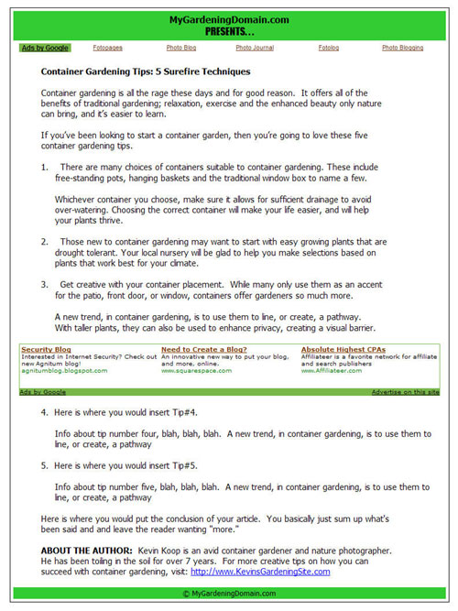

A simple web template is all that’s needed. Here’s a rundown of some of the features I like:

- “Header” space for the affiliates Header Graphic or Domain Name
- A table provided for a “728 x 15 pixel Link Unit” (under the Header)
- The start of the Article Content
- A table for a “728 x 90 pixel Leaderboard” which separates the article
- The ability for the affiliate to use their Affiliate Link in the Resource Box
- “Footer” space for the affiliate Footer Graphic or other information

Note: You received a package of (9) Header/Footer graphics and pre-formatted templates as a Bonus with your Article Domination Method purchase. Watch the screen-capture video and you’ll see just how easily (and quickly) you can get these up and running!

- Send a mailing to your list telling them about one of your new articles. Include “teaser-text” and ask them to visit your website to read it. Note: You may also decide to put a link on the bottom of each “Article Marketing Template” page which lets the reader navigate to a page which contains links to all of the articles available on your site.
- If you have a blog, post an article every 2-3 days. Make sure to tell your list about a few of the better posts.
- Now it’s time to submit to the directories. Sure, you could submit all ten at once, but I wouldn’t recommend it as some directories have a limit on the maximum amount of articles an author can submit in one day.

I’d suggest submitting four articles at once, and then two articles per week thereafter. If you follow this schedule, you will have articles to submit for an entire month.
- If you really want to get aggressive, contact some magazine or newspaper publishers and see if they’d be interested in publishing your articles. I haven’t started doing this yet, but it’s worked great for Internet Marketer Jim Edwards!

To review, each of our articles can now be found on our own site, our affiliate’s sites, and our blogs. They can also be found in countless article directories. If well written, they will also be picked up by Ezine Publishers, Blog Publishers and Website Publishers.

While I can’t make you any guarantees, I’ve personally had one article create more than 500 backlinks to one of my sites in under three weeks!
In the next section, I’ll show you 33 of my favorite article directories and show you how to quickly evaluate them.

33 Quality Article Directories You Can Submit To For FREE
While there are literally hundreds of Article Directory sites, here are 33 quality sites I can highly recommend. Following this listing, I will explain the information it contains and its importance to the Article Marketer.

PageRank Website URL Alexa Rank
0* www.365Articles.com 73,496
4 www.Add-Articles.com 77,481
4 www.ArticleBar.com 153,690
4 www.ArticleBeach.com 53,680
6 www.ArticleCity.com 8,863
6 www.ArticleDashboard.com 5,054
3 www.ArticleFarm.com 205,474
4 www.ArticleHub.com 63,441
3 www.ArticleNexus.com 88,557
3 www.ArticlePeak.com 100,828
4 www.ArticlePros.com 62,127
5 www.ArticleSphere.com 20,442
4 www.ArticleTime.com 260,345
4 www.ArticleToGo.com 130,884
4 www.ArticleWiz.com 156,545
5 www.Article99.com 43,120
3 www.Articles411.com 84,849
5 www.BigArticles.com 77,448
6 www.Buzzle.com 8,107
6 www.Constant-Content.com 24,334
4 www.ContentDesk.com 21,130
5 www.EasyArticles.com 50,500
0* www.EzineArticles.com 467
3 www.GetYourArticles.com 216,614
6 www.GoArticles.com 2,753
6 www.ISnare.com 6,397
5 www.LinkSnoop.com 108,024
5 www.Marketing-Seek.com 137,279
4 www.NewArticlesOnline.com 166,747
7 www.PromotionWorld.com 23,118
3 www.ReprintArticles.com 233,131
4 www.SubmitYourNewArticle.com 58,257
3 www.TheArticleZone.com 97,890
Now that you’ve seen the list, I’ll quickly explain the information it contains.

In the first column, you see a heading entitled “PageRank.” This is Google’s proprietary system and is an indication of how “important” Google believes any individual web page to be. Google’s maximum value for PageRank is 10, and a higher value is better.

The middle column is self-explanatory; it contains the Article Directories’ URL.

The last column, entitled “Alexa Rank” is a proprietary system of Alexa.com It tracks website traffic and assigns a value to each site relative to all websites on the internet. For example, if you look at the Alexa Rank for EzineArticles.com you see the number “467.”

This means that EzineArticles.com is the 467th MOST visited website on the internet. The lower the Alexa Rank; the more traffic the site is getting!

As an Article Marketer, this information is invaluable! If you’re only going to submit to a few sites, choose ones that Google favors and are getting as much traffic as possible. This way, you’ll have a much better chance that Publishers will pick up your article(s) and put them on their sites.

*Note: When compiling this information I found two aberrations in regards to PageRank. Until recently, 365Articles.com was a PageRank 4 site and EzineArticles.com was a PageRank 6. I’m not sure this information is accurate, it may be a glitch. Even so, EzineArticles.com is still my favorite submission site.

If you don’t want to submit to them all, here’s my TOP TEN…

- www.EzineArticles.com
- www.ArticleCity.com
- www.ArticleDashboard.com
- www.GoArticles.com
- www.ISnare.com
- www.PromotionWorld.com
- www.ArticleSphere.com
- www.Constant-Content.com
- www.ContentDesk.com
- www.BigArticles.com

All 33 of the directories I’ve listed are very good. However, if you plan to do your submissions yourself, I’d suggest starting with these ten and increasing your distribution in the future.

Note: I also love Buzzle.com but they are the most stringent in regards to allowing new authors in and it will generally take two weeks before you find out if you were accepted.

When you’re ready for more sites, you can find 505 of them at:
http://www.styopkin.com/article_submission_sites.html

Summary

Now that you’ve seen the “Article Domination Method,” and have witnessed its power in bringing targeted website traffic, I sincerely hope you’ll put it into practice.

Yes, it does require some effort on your part, but that effort can bring you lots of traffic AND sales through the power of leverage. After all, at the end of the day, the “Article Domination Method” is immersed in two concepts: efficiency and leverage.

While the bulk of the “teaching” is complete at this point, make sure to read the remaining sections as they contain valuable information and resources.

Valuable Resources

Resource #1: Here’s a free piece of software which makes formatting articles a breeze. I’m not only going to tell you about the software, I’m also going to show you how to set it up to format your articles to perfection.

The software is called NoteTab Light (current version is 4.95). While it’s “freeware,” it is a high-quality piece of software that does not contain a bunch of annoying ads. You can download it at: http://www.notetab.com

Before I cover the set-up, you need to know why this is so important. You see, most Article Directory editors require that authors submit articles which contain no more than 60 characters per line, contain no “word processing” formatting, and do not have “hard line breaks” after each sentence. Note: A “hard line break” occurs whenever you hit the [Enter] key on your keyboard and should only be used between paragraphs.
After downloading, installing and opening the program, you’ll see this window:
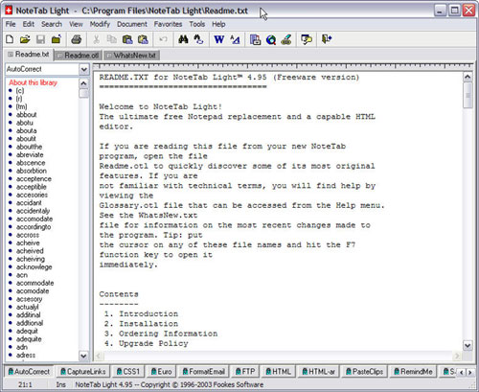
Before you format your articles, you’ll need to set-up a few things. From the top menu, select [View] then [Options] to open the Options Window. Once there, select the “Documents” tab. In the “Documents” tab you’ll change two settings.

First, “tick” the box next to the text, “Wrap to Column:” and make sure the value is set to “60” characters. When this is done, click the [OK] button to save your settings.

This screen-shot shows the layout of the Options Window.
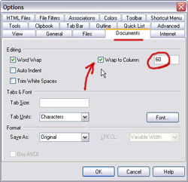

Now that the settings have been saved, create a new page and paste your article’s text into it. You will see something like this:

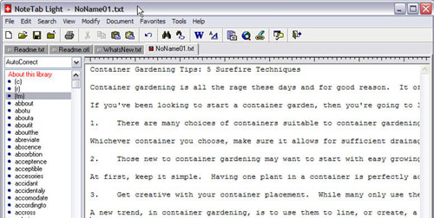

I’ve pasted-in the article I originally created in Microsoft Word. NoteTab Light automatically strips the hidden “Word” formatting. As you can see, the sentences are really long and the formatting looks terrible.

To improve our formatting, and to automatically force the sentence length to be 60 characters long, do the following: Select all of the text, and choose [Modify] from the top menu. After this, choose [Lines] and then select [Split Lines].

This will clean up our formatting and will force our sentence length to 60 characters long. The “before” and “after” is shown below:
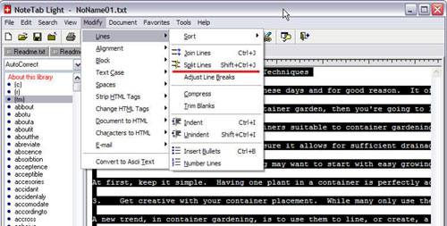

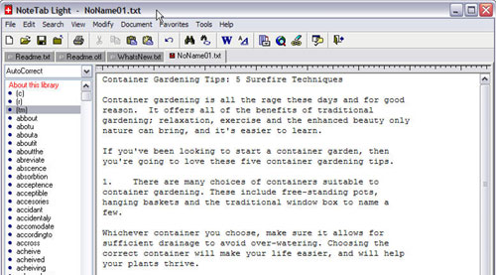
As you can see, our article formatting looks real nice and has been forced to no more than 60 characters per line. The “Word” formatting and any unnecessary “hard breaks” have also been removed and our article is ready for submittal.

While it might not seem like a big deal, this is a really important step! I have had articles “kicked-back” to me by Editors before following this process and having to re-format and re-submit an article is a huge waste of time!

Another cool feature of NoteTab Light is called “Text Statistics.” To view the “Text Statistics,” first highlight the text you’d like to evaluate. With the text “selected,” select [Tools] from the top menu and choose [Text Statistics].

This will open the “Text Statistics” window and will tell you the total number of characters and the word count for your selected text. To dig even deeper, click the [More] button and you will see the window below:
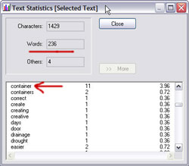

In this window, not only can you see the character and word count, you can also find out the frequency (in percentage) of every word you’ve used in your article. It won’t show you the “density” for a keyword phrase (meaning more than one word, like “Container Gardening”) but it will show you the “density” for any given word.

The word “container,” at the top of the screen, shows a frequency (or density) of 3.96%

Resource #2: As mentioned earlier, it’s wise to use trackable links in your resource boxes. This is important for several reasons:

- It allows you track your traffic to determine which “traffic sources” are bringing you the most success.
- It allows you to “cloak” a link should you decide to include affiliate links in your resource box.
- It gives you complete control over the link. If you decide you want to change the destination URL of the link in the future, you simply go back into your “link management” utility and make the change.

Currently, I’m using two different “link management” utilities and I’ll give you a quick rundown of each:

Power Link Generator:

Power Link Generator is a product by Mike Filsaime. It is a script that installs on your domain and is very easy to use.

Pro’s –

- If you’re not comfortable installing scripts, they’ll do it for a small fee
- Great layout, easy to learn and use
- Tracks each and every click made on your link
- Protects from “affiliate hijacking”
- Provides a nice clean link (no more UGLY links)
- Allows you to create a “Redirect” link
- Allows you to create a “Cloaked” link
- Allows you to bypass a squeezepage and go directly to the Sales Letter
- A reasonable one-time payment of $97
- No limit as to the amount of sites you can install it on
- A whole bunch more

Con’s –

The only thing I don’t like about Power Link Generator is the directory path that’s forced upon you. You have to install “PLG” in a folder, which is normally named “recommends.” If I create a link for Article Submitter for instance, my link looks like this: http://www.kevin-koop.com/recommends/ArticleSubmitter

Now, this looks a whole lot better than most affiliate links but I don’t like it for two reasons.

- It makes your links unnecessarily long
- The word “recommends” still makes someone “feel” like they’re being sold

Note: You can name the folder anything you want. Some other alternatives I’ve seen are “reviews,” “introduces,” and “uses.” Of the three, I like “uses” the best, as it’s shorter and feels a little less “hypey.”

Click here to check out PLG: http://www.PowerLinkGenerator.com

Go Try This:

Go Try This is a product by John Reel. Like “PLG,” it’s a script that installs on your domain.

Pro’s –

- If you’re not comfortable installing scripts, they’ll do it for a small fee
- Awesome link tracking and graphical stats
- Creates a short, professional link (no folder required!)
- Protects from “affiliate hijacking”
- Currently, it’s a one-time payment of $47
- Easy to use
- Allows you to create a “Redirect” link
- Allows you to create a “Cloaked” link
- And much more!

Con’s –

While simple to use, the interface isn’t as intuitive as Power Link Generators (in my humble opinion). The cost is lower, but you’re only allowed to install it on one domain.

Note #1: The links look great! Using our previous example, a “Go Try This” link would look like: http://www.XYZDomain.com/ArticleSubmitter Not only is the link shorter, it has a professional, “non-hypey” appearance!
(please note: this link goes absolutely nowhere!)
Note #2: “Go Try This” is about to be upgraded to “version 2.” Current owners will be upgraded for free but I’ve been told that version 2 will cost more when it’s released.

Note #3: The company hasn’t released a price, but a “multiple-domain” license is going to be available in the near future. I’m guessing they’ll make it available when they release version two.

Click here to check out Go Try This: http://www.GoTryThis.com

Resource #3: One of the benefits of the “Article Domination Method” is a large influx of “backlinks.” Here’s a site that will allow you to keep track of your progress: http://www.MarketLeap.com

Once you’re on the site, click the “Link Popularity Check” link near the center of the screen. Enter your site’s URL, the “access code” and click the [Generate Code] button.

MarketLeap will tell you the total links found and give you a breakdown of where it found them (i.e. Google, MSN or Yahoo!)

In the next section, I’ll list several Resources of interest to Internet Marketers.

Internet Marketing Resources

While there are countless internet marketing products available, here’s a few I’ve personally found useful in building my business:

7 day ebook – This product, by Jim Edwards and Joe Vitale is the one that started everything for me. If you’d like to create your own ebook(s), but don’t know how to start, give this a look.

Desktop Bucks – If you’re a beginning to intermediate marketer, you will find a “treasure trove” of information here. This site is the product of Armand Morin and Kevin Rohan and offers quality information in a variety of formats (including lots of videos).

As a customer of mine, you’ll receive a free membership but please understand that I have no control as to how long this will be offered.
Ultimate Lifestyle Workshop Audios – This is an audio series produced by my main “coach,” Matt Bacak, and his good friend Mike Litman. Both Matt and Mike have authored best-selling books and have sold millions of dollars of info products online. In this series, they dissect the information product market and give tons of real-world advice to help you succeed.

Video Traffic Power – This is a product of Jonathan Leger. It teaches Internet Marketers how to quickly (& cheaply) make “slide-show” type videos that can be uploaded to places like Google Video and YouTube. It’s reasonably priced and the instruction is great! Following Jon’s advice, I completed my first video in under 45 minutes and my second in about a half-an-hour.

Making these videos was a whole lot of fun and have brought me targeted visitors and subscribers… all this for free.

33 Days To Online Profits – This product comes on two CD-Roms and contains
41 videos totaling more than 3 hours of instruction. Basically, you watch over the shoulders of copywriting “superstar” Yanik Silver and Internet Marketer Jim Edwards as they teach everything from Autoresponders to Website Conversion.

The product isn’t “cheap,” but it does contain high-quality information from two guys who are making millions online. In my opinion, the best information comes as Yanik and Jim show how to write a cash-sucking sales letter! Learning to write compelling copy can make or break your online business and the instruction this product contains is solid and easy to follow.

Resell Rights For Newbies – If you don’t have a product of your own, selling “Resell Rights” products may be the best way to start. This site is a product of Liz Tomey and John Hostler and offers free membership and lots of quality instruction in regards to resell rights products.

Secret Affiliate Weapon – While I’ve purchased, and studied, many affiliate marketing related products, I have learned the most from “super-affiliate” Ewen Chia. If you’re just getting started with affiliate marketing, Secret Affiliate Weapon is a great place to start!

$7 Secrets Method – Here is a product, no a method, that is pure genius! Jonathan Leger teaches how you can write a short 20-30 page report and get it up on the web fast. In addition to the instruction, Jonathan gives you the scripts that will make your sales viral. Many, including myself, are currently using this method with great success and it’s a measly 7 Bucks!

Make Money With This Book

Now that you’ve seen the power of the Article Domination Method, I encourage you to go out there and make yourself some money with it!

The ArticleDomination.com site is set up with the “$7 Secrets Method” scripts I told you about earlier.

The scripts allow anyone to immediately become an affiliate without having to sign up. You simply send traffic to ArticleDomination.com with the following link:

http://www.ArticleDomination.com/?e=YourPayPalAddress.com

NOTE: You must replace “YourPayPalAddress.com” with the email address you’ve registered with PayPal.

Doing this, you’ll receive 100% of the front-end sale (currently $27 and going up in the near future) and 50% of the one-time-offer which is $67 (commission= approx. $33 minus PayPal costs)

SPECIAL NOTE:

You’re not really going to get 50% of the one-time-offer sales… You’re going to get 100% of every other sale.

This can be somewhat confusing so I’ll do my best to explain.

Say you send 100 visitors to ArticleDomination.com and 5 buy the Article Domination Method and 2 of those, purchase the “one-time-offer.”

You’ll receive $27 (current price) x 5 sales = $135
You’ll also receive (1) of the two “oto” sales = $67

In this example, you’d make $202 in commissions. I just wanted you to be aware so that when you start getting $67 commissions coming into your PayPal account, you won’t worry.
Also, I’ve set up an Affilate Page where you can find graphics and other helpful items to improve your promotional capabilities.

You’ll find the affiliate page at:

http://www.articledomination.com/aff_center.html

Happy Promoting,

Kevin A. Koop

About the Author

God has blessed me with a beautiful (and talented) wife, Christi and an outrageously-wonderful daughter, Sydnee. My wife owns/operates K2 Graphix, a graphic design and advertising business specializing in design for print work, packaging and websites.

I've been involved with sales, marketing and copywriting for over 20 years. I've worked for others, owned a cabinet shop and now own my own Internet Marketing and Consultation company, KCS Enterprises & Marketing, Inc.

While Internet Marketing takes an investment of time, money and effort, I have found it to be both fun and profitable. I’ve also had the pleasure to meet many wonderful people as I’ve traveled across the globe in my studies.

Here are some pictures of a few of the “notable” Internet Marketers I’ve
had the pleasure to meet and study from:


From Left-to-Right: 1. With Matt Bacak (the “Powerful Promoter”) in Atlanta, Ga. Matt’s become a good friend and my primary “coach.” 2. With Yanik Silver (Copywriting Guru) at his Underground UK seminar in London, England 3. With Jim Edwards (of The Net Reporter) aboard the “Jim Boat;” somewhere in the Caribbean. 4. With Mike Stewart (the Internet Audio/Video Guy) aboard the “Jim Boat.”

I want to end this with a quote that continues to drive and motivate me. I wish I knew who said it, but I don’t. The quote goes… “In order to exceed beyond your wildest imaginations; you have to START WITH WILD EXPECTATIONS!” I hope that fuels you to greater heights in 2007 and beyond!

